

# [Project]

**DETAIL DESIGN DOCUMENT**

**Screen design**

**Project Code:**

**Document Code: <Project code>-DD – v<Version>**

**<Location, issued date of the Document>**

**RECORD OF CHANGE**

#### *A - Added M - Modified D – Deleted

|  |  |  |  |  |
| --- | --- | --- | --- | --- |
| Effective Date | Changed Items | A* M, D | Change Description | New Version |
|  |  |  |  |  |
|  |  |  |  |  |
|  |  |  |  |  |
|  |  |  |  |  |
|  |  |  |  |  |
|  |  |  |  |  |
|  |  |  |  |  |
|  |  |  |  |  |
|  |  |  |  |  |
|  |  |  |  |  |
|  |  |  |  |  |
|  |  |  |  |  |
|  |  |  |  |  |

**SIGNATURE PAGE**

**ORIGINATOR:**<Name> <Date>

#### <Position>

**REVIEWERS:** <Name> <Date>

#### <Position>

<Name, if it’s needed> <Date>

<Position>

**APPROVAL:** <Name> <Date>

#### <Position>

1. INTRODUCTION 5
   1. Purpose 5
   2. Definitions, Acronyms and Abbreviations 5
   3. References 6
   4. Overview 6
2. SCREEN FLOW 7
   1. xxx screen 8
3. OTHER CONSIDERATIONS 9

### INTRODUCTION

## Purpose

This part will give general description of the document including:

* + - *Purpose of document.*
    - *What are contained in the doc*
    - *Reader of document*
    - *Other description about scope of document, limitation,...*

## Definitions, Acronyms and Abbreviations

|  |  |  |
| --- | --- | --- |
| **Abbreviations** | **Description** | **Comment** |
| *TBD* | *To be decided* | *It means “not decided yet”* |
|  |  |  |
|  |  |  |
|  |  |  |
|  |  |  |

## References

List of the reference document such as: other document of the system, or the technical article,...

|  |  |
| --- | --- |
| **Document Number** | **Title** |
|  |  |
|  |  |
|  |  |
|  |  |
|  |  |
|  |  |
|  |  |
|  |  |
|  |  |
|  |  |
|  |  |

## Overview

General overview of the detail design such as what is the structure of the document

### SCREEN FLOW

<Screen structure or transition between screens. It should be in diagram>

<List of screen>

|  |  |  |
| --- | --- | --- |
| **No** | **Screen Name** | **Description** |
|  |  |  |
|  |  |  |
|  |  |  |
|  |  |  |
|  |  |  |
|  |  |  |
|  |  |  |

## Business screen

1. Business screen

<screen’s component list, table below is suggestion>

|  |  |  |  |  |  |
| --- | --- | --- | --- | --- | --- |
| **No** | **Component Name** | **Required** | **Format** | **Reference** | **Note** |
|  | Trang cá nhân |  |  | *Use Linearlayout:*  *Use ImageView:*   * *width: 20dp* * *height: 30dp*   *Use TextView:*   * *TextSize: 16dp* * *Color: #435154* * *TextStyle: Bold* |  |
|  | Chỉnh sửa bài đăng |  |  | *Use Linearlayout:*  *Use ImageView:*   * *width: 20dp* * *height: 30dp*   *Use TextView:*   * *TextSize: 16dp* * *Color: #435154* * *TextStyle: Bold* |  |
|  | Danh sách tour |  |  | *Use Linearlayout:*  *Use ImageView:*   * *width: 20dp* * *height: 30dp*   *Use TextView:*   * *TextSize: 16dp* * *Color: #435154* * *TextStyle: Bold* |  |
|  | Tour khách đặt |  |  | *Use Linearlayout:*  *Use ImageView:*   * *width: 20dp* * *height: 30dp*   *Use TextView:*   * *TextSize: 16dp* * *Color: #435154* * *TextStyle: Bold* |  |
|  | Đăng xuất |  |  | *Use Linearlayout:*  *Use ImageView:*   * *width: 20dp* * *height: 30dp*   *Use TextView:*   * *TextSize: 16dp* * *Color: #435154* * *TextStyle: Bold* |  |

## Infor Business screen

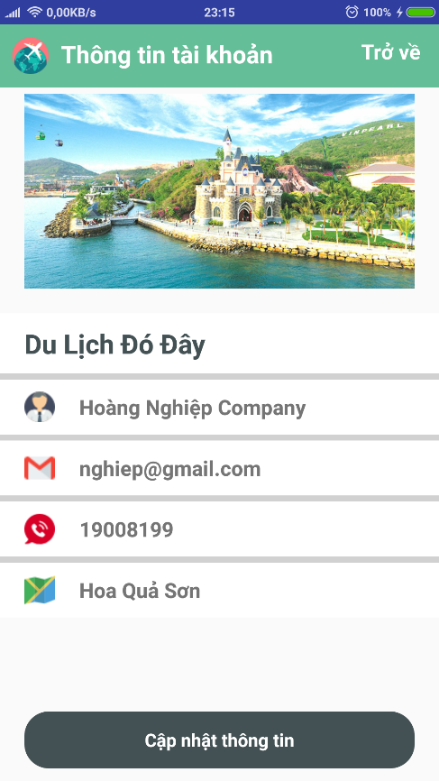

2. Infor Business screen

<screen’s component list, table below is suggestion>

|  |  |  |  |  |  |
| --- | --- | --- | --- | --- | --- |
| **No** | **Component Name** | **Required** | **Format** | **Reference** | **Note** |
|  | ImageView |  |  | *Use ImageView* |  |
|  | Name Business |  |  | *Use TextView:*   * *TextSize: 22dp* * *Color: #435154* * *TextStyle: Bold* |  |
|  | Email business |  |  | *Use TextView:*   * *TextSize: 17dp* * *Color: #435154* * *TextStyle: Bold* |  |
|  | Phone business |  |  | *Use TextView:*   * *TextSize: 17dp* * *Color: #435154* * *TextStyle: Bold* |  |
|  | Address |  |  | *Use TextView:*   * *TextSize: 17dp* * *Color: #435154* * *TextStyle: Bold* |  |

## Update infor Business screen

3. Update Infor Business screen

<screen’s component list, table below is suggestion>

|  |  |  |  |  |  |
| --- | --- | --- | --- | --- | --- |
| **No** | **Component Name** | **Required** | **Format** | **Reference** | **Note** |
|  | ImageView |  |  | *Use ImageView:* |  |
|  | Ô Tên doanh nghiệp |  |  | *Use EditText*  *singleLine="true"*  *Color: #435154* |  |
|  | Ô Số điện thoại |  |  | *Use EditText*  *singleLine="true"*  *Color: #435154* |  |
|  | Ô Địa chỉ |  |  | *Use EditText*  *singleLine="true"*  *Color: #435154* |  |
|  | Nút Cập nhật thông tin |  |  | *Use TextView:*  *Gravity: center*  *TextSize: 15dp*  *TextStyle: bold*  *Color: #FFFFF* |  |
|  |  |  |  |  |  |

## Manager tour screen

4. Manager tour screen

<screen’s component list, table below is suggestion>

|  |  |  |  |  |  |
| --- | --- | --- | --- | --- | --- |
| **No** | **Component Name** | **Required** | **Format** | **Reference** | **Note** |
|  | Tour item |  |  | *Use RecyclerView custom* |  |
|  | Butom Add |  |  | *Use ImageView*  *Width="40dp"*  *Height="40dp"* |  |
|  | Image tour |  |  | *Use ImageView*  *Width: 120dp*  *Height: 120dp* |  |
|  | Id tour |  |  | *Use TextView*  *TextStyle: bold*  *TextColor: #64be97* |  |
|  | Name tour |  |  | *Use TextView*  *TextColor: #000000*  *TextSize: 17sp* |  |
|  | Time Tour |  |  | *Use TextView*  *TextSize: Default* |  |
|  | Price tour |  |  | *Use TextView*  *TextColor: Red_dark*  *TextSize: Default* |  |
|  | Menu Tour |  |  | *Use TextView*  *TextSize: Default* |  |

## Add tour screen

5. Add Tour screen

<screen’s component list, table below is suggestion>

|  |  |  |  |  |  |
| --- | --- | --- | --- | --- | --- |
| **No** | **Component Name** | **Required** | **Format** | **Reference** | **Note** |
|  | ImageView |  |  | *Use ImageView*  *Width="150dp"*  *Height="150dp"* |  |
|  | Chọn miền |  |  | *Use RadioButton*  *TextColor="#ffffff"*  *TextStyle="bold"*  *TextSize="Default"* |  |
|  | Ô Mã tour |  |  | *Use EditText*  *SingleLine="true"*  *Color: #435154* |  |
|  | Ô tên tour |  |  | *Use EditText*  *SingleLine="true"*  *Color: #435154* |  |
|  | Ô thời gian |  |  | *Use EditText*  *SingleLine="true"*  *Color: #435154* |  |
|  | Ô mô tả chi tiết |  |  | *Use EditText*  *SingleLine="true"*  *Color: #435154* |  |
|  | Ô giá tiền |  |  | *Use EditText*  *SingleLine="true"*  *Color: #435154* |  |
|  | Nút thêm |  |  | *Use TextView*  *gravity="center"*  *textSize="15dp"*  *textStyle="bold"*  *textColor="#ffffff"* |  |

## Update Tour screen

6. Update Tour screen

<screen’s component list, table below is suggestion>

|  |  |  |  |  |  |
| --- | --- | --- | --- | --- | --- |
| **No** | **Component Name** | **Required** | **Format** | **Reference** | **Note** |
|  | ImageView |  |  | *Use ImageView*  *Width="150dp"*  *Height="150dp"* |  |
|  | Chọn miền |  |  | *Use RadioButton*  *TextColor="#ffffff"*  *TextStyle="bold"*  *TextSize="Default"* |  |
|  | Ô mã tour |  |  | *Use EditText*  *SingleLine="true"*  *Color: #435154* |  |
|  | Ô tên tour |  |  | *Use EditText*  *SingleLine="true"*  *Color: #435154* |  |
|  | Ô thời gian |  |  | *Use EditText*  *SingleLine="true"*  *Color: #435154* |  |
|  | Ô mô tả chi tiết |  |  | *Use EditText*  *SingleLine="true"*  *Color: #435154* |  |
|  | Ô giá tiền |  |  | *Use EditText*  *SingleLine="true"*  *Color: #435154* |  |
|  | Nút cập nhật |  |  | *Use TextView*  *gravity="center"*  *textSize="15dp"*  *textStyle="bold"*  *textColor="#ffffff"* |  |

## Tour List screen

7. Tour list sscreen

<screen’s component list, table below is suggestion>

|  |  |  |  |  |  |
| --- | --- | --- | --- | --- | --- |
| **No** | **Component Name** | **Required** | **Format** | **Reference** | **Note** |
|  | Item tour |  |  | *Use RecyclerView custom* |  |
|  | Image tour |  |  | *Use ImageView*  *Width: 120dp*  *Height: 120dp* |  |
|  | Tour ID |  |  | *Use TextView*  *TextStyle: bold*  *TextColor: #64be97* |  |
|  | Tour name |  |  | *Use TextView*  *TextColor: #000000*  *TextSize: 17sp* |  |
|  | Tour Time |  |  | *Use TextView*  *TextSize: Default* |  |
|  | Tour Price |  |  | *Use TextView*  *TextColor: Red_dark*  *TextSize: Default* |  |

## Manager Book Tour screen

6. Tour list sscreen

<screen’s component list, table below is suggestion>

|  |  |  |  |  |  |
| --- | --- | --- | --- | --- | --- |
| **No** | **Component Name** | **Required** | **Format** | **Reference** | **Note** |
|  | Item tour |  |  | *Use RecyclerView custom* |  |
|  | Image tour |  |  | *Use ImageView*  *Width: 120dp*  *Height: 120dp* |  |
|  | Tour ID |  |  | *Use TextView*  *TextStyle: bold*  *TextColor: #64be97* |  |
|  | Tour name |  |  | *Use TextView*  *TextColor: #000000*  *TextSize: 17sp* |  |
|  | Tour Time |  |  | *Use TextView*  *TextSize: Default* |  |
|  | Tour Price |  |  | *Use TextView*  *TextColor: Red_dark*  *TextSize: Default* |  |

### OTHER CONSIDERATIONS

[This section provides a description of other design elements that were considered as alternatives in selection process for the above screen design, i.e. a brief explanation of advantages and disadvantages of the selected screen flows and/or screen GUI element implementation in comparison with others. It should be a clear answer to the question why the above screen design is selected for this system, not the others.]